You are viewing the Icons on the West End of the Nave

Saint Nectarios Greek Orthodox Church and Shrine

Home | About_Us | Calendar | Bulletin | Ministries | Sacraments/Blessings | Donations | Our_Faith | Stewardship | Church_Hall

Icons on the west end of the nave

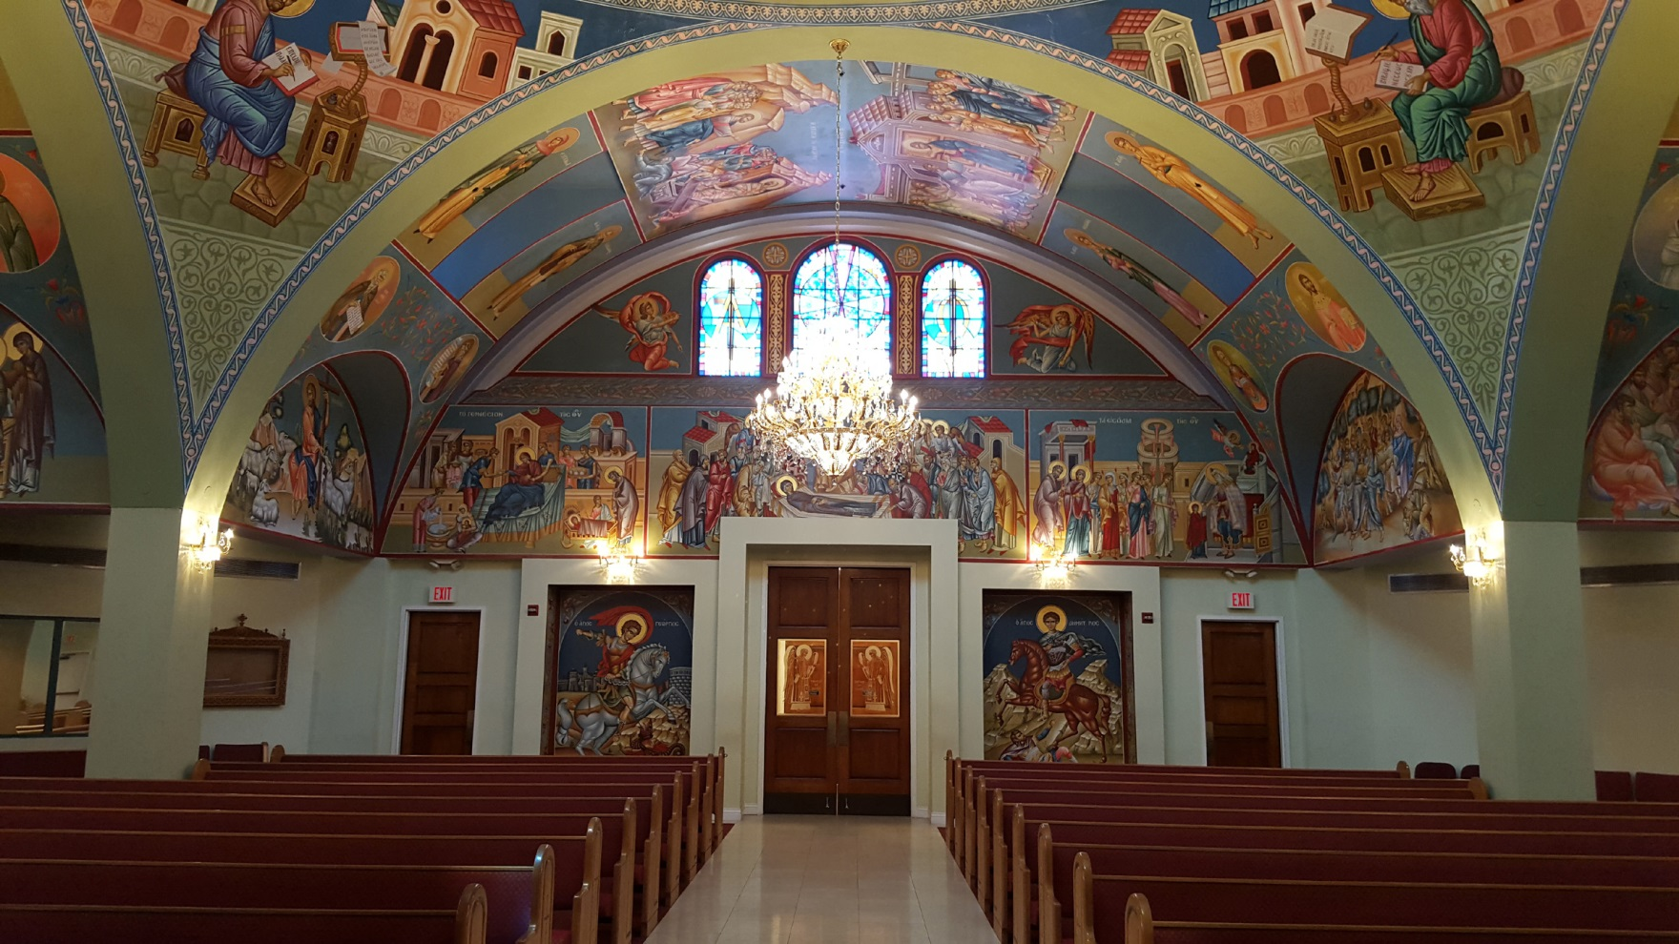

The art on the west end of the nave and its arc ceiling. The Main Entrance doors is shown here at the center and on the left and right side are two exit doors.

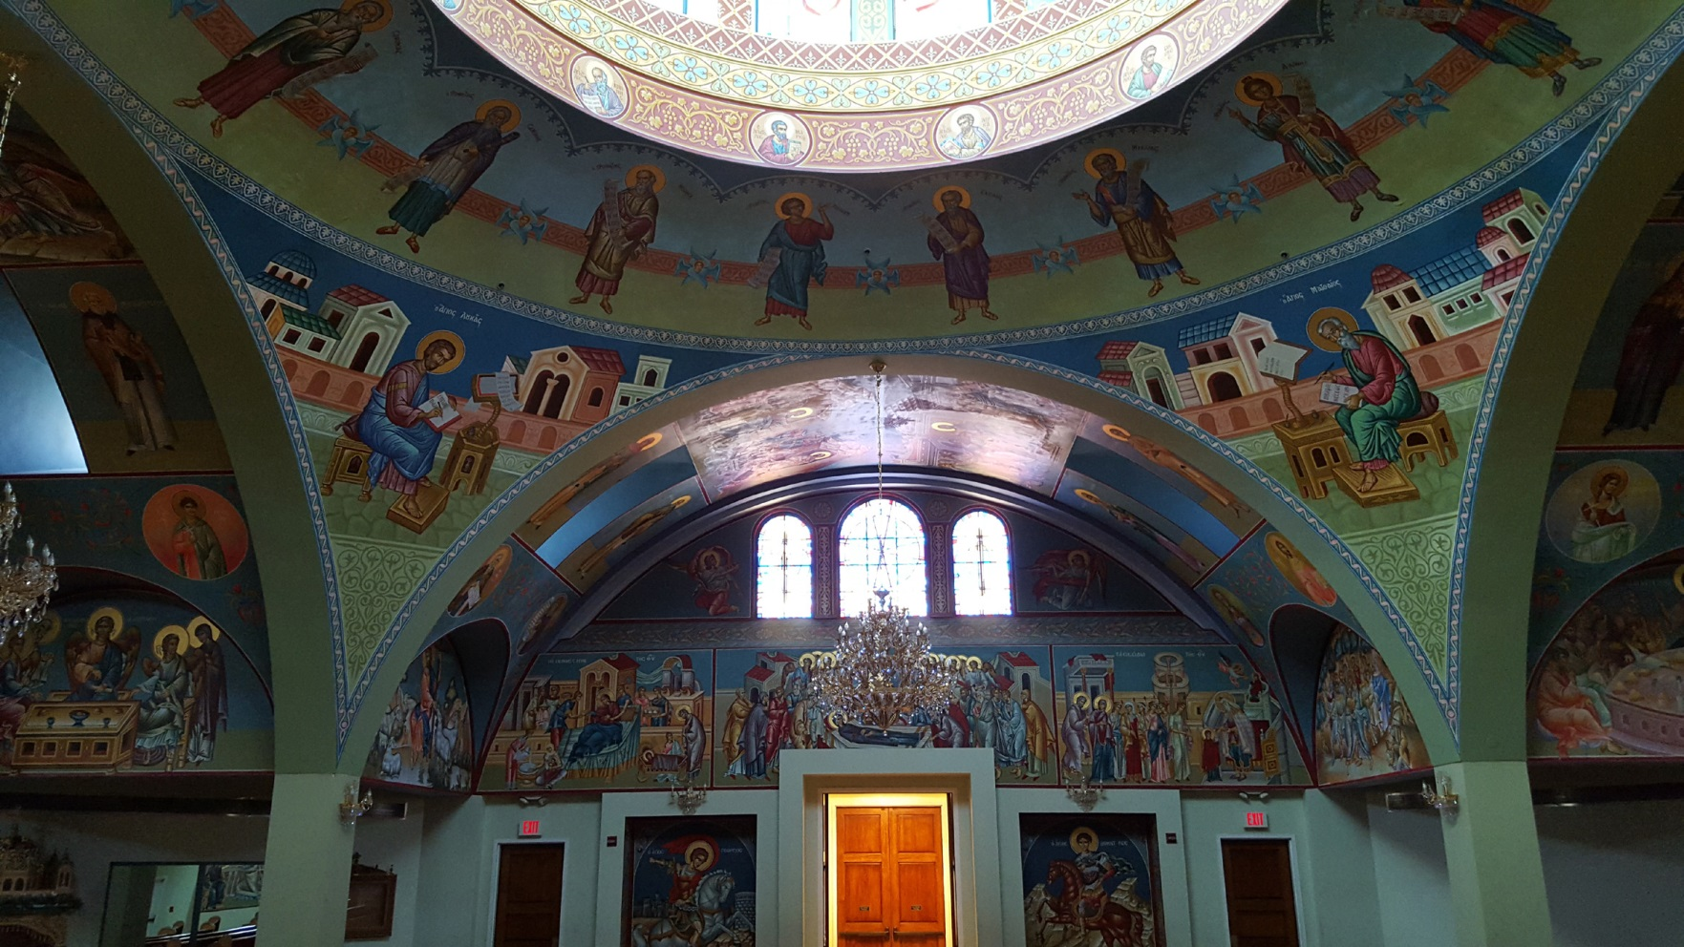

 | PREVIOUS PAGE |  | NEXT PAGE

|About Us | Contact Us | Visitor Info | Donate | Our Faith | Ministries | Calendar | Metropolis News | Archdiocese News |Sacraments|

© 2017 Saint Nectarios Greek Orthodox Church and Shrine. This site has been designed and developed by Joey M. Eugenio and hosted by WebSBA

