You are viewing the Baptistery

Saint Nectarios Greek Orthodox Church and Shrine

Home | About_Us | Calendar | Bulletin | Ministries | Sacraments/Blessings | Donations | Our_Faith | Stewardship | Church_Hall

Baptistery

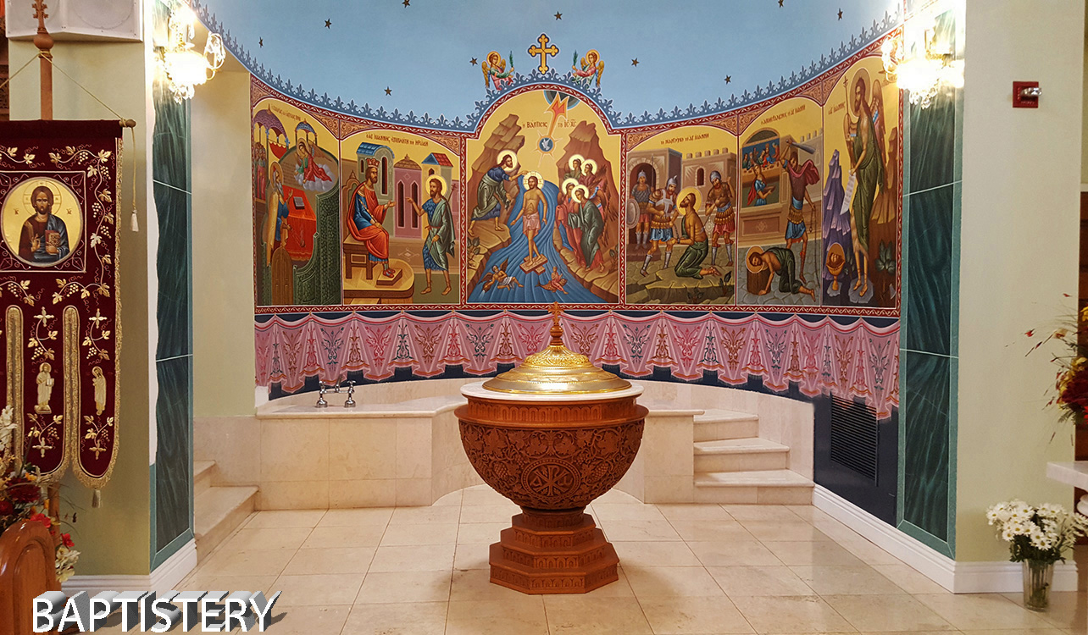

Showing here are baptismal font and immersion font.

Baptismal Font – is intended for baptism immersion of infant. The font has wooden pedestal (about 1.5 meter tall) with a wooden holder for a marble top and silver basin for holding water. It has a golden lid.

- Immersion Font – is intended for baptism immersion of adult. The font is made of marble with three steps leading to the pool and three steps leading to the bottom.

Baptism is always by full immersion even in the case of infant baptism. During baptismal service, three candles will lit on or around the baptismal font, in honor of the Holy Trinity. In many Orthodox churches, a very special kind of holy water called “Theophany Water” is consecrated on the Feast of Theophany (Epiphany). The consecration (literally, “Great Blessing”) is performed twice as follows:
- In a baptismal font on the Eve of the feast.
- In a natural body of water on the Day of feast

BAPTISM
The Sacrament of Baptism incorporates us into the Church, the Body of Christ, and is our introduction to the life of the Holy Trinity. Water is a natural symbol of cleansing and newness of life. Through the three-fold immersion in the waters of Baptism in the Name of the Holy Trinity, one dies to the old ways of sin and is born to a new life in Christ. Baptism is one's public identification with Christ Death and victorious Resurrection. Following the custom of the early Church, Orthodoxy encourages the baptism of infants. The Church believes that the Sacrament is bearing witness to the action of God who chooses a child to be an important member of His people. From the day of their baptism, children are expected to mature in the life of the Spirit, through their family and the Church. The Baptism of adults is practiced when there was no previous baptism in the name of the Holy Trinity.

 | PREVIOUS PAGE |  | NEXT PAGE

|About Us | Contact Us | Visitor Info | Donate | Our Faith | Ministries | Calendar | Metropolis News | Archdiocese News |Sacraments|

© 2017 Saint Nectarios Greek Orthodox Church and Shrine. This site has been designed and developed by Joey M. Eugenio and hosted by WebSBA

