You are viewing The Holy Altar and Tabernacle Page

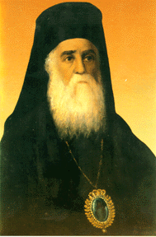 | Saint Nectarios Greek Orthodox Church and Shrine | 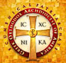
Home | About_Us | Calendar | Bulletin | Ministries | Sacraments/Blessings | Donations | Our_Faith | Stewardship | Church_Hall

The Holy Altar and Tabernacle

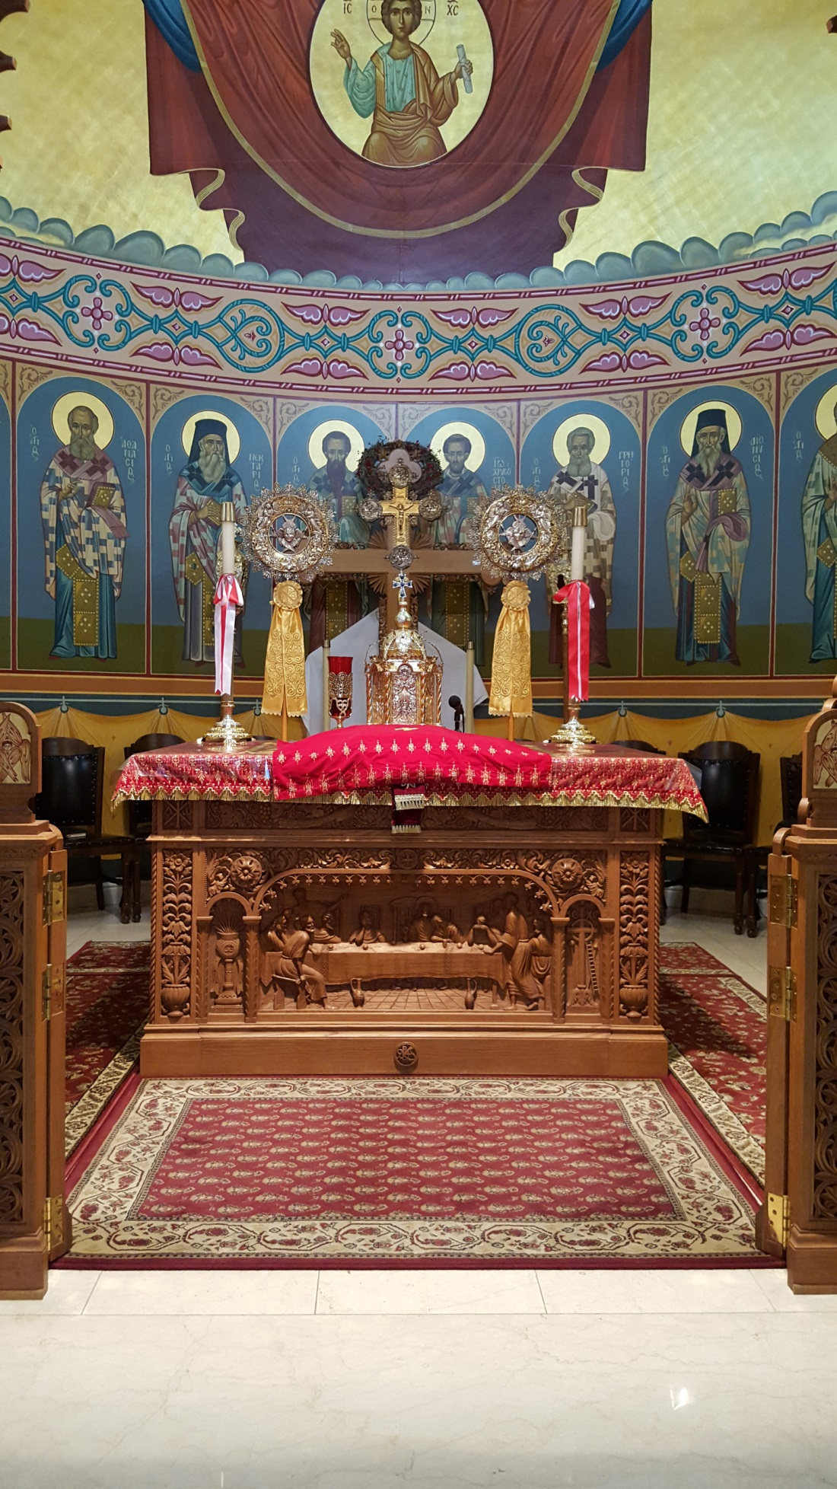

ALTAR

The altar is the area at the east end of a church, behind an iconostasis (altar screen). The word (Hebrew: מזבח -‎ mizbe'ah - altar) means "a place of sacrifice" in Hebrew (Greek. ἱερόν θυσιατήριον - hieron thysiasterion; Sl. prestol). The altar often is also referred to as the sanctuary. An Altar Table is located in the center of the altar as one enters through the Royal Doors in the iconostasis. This table is often referred to as the Holy Table.

ALTAR TABLE

The altar table is a cube with each dimension of about one meter or cubit. The table is made of wood. The table is covered with a brocade covering, the color of which changes with the liturgical season. Atop the altar table is the tabernacle, a miniature shrine built in the form of a church, inside of which is a small ark containing the reserved Sacrament for use in communing the sick. Also, a multi-branch candle stand, usually with seven candles, is placed near the back of the table as one looks from the nave. Also kept on the altar is the book of the Gospels and the antimension, a silken cloth imprinted with an icon of Christ being prepared for burial, which has a relic sewn into it and bears the signature of the bishop. The Divine Liturgy must be served on an antimension even if the altar has been consecrated and contains relics. When not in use, the antimension is left in place wrapped in the eileton, a cloth of plain silk, linen, or cotton.

The Holy Altar has multiple symbolic meanings. First, it represents the Throne of God because through the sacraments celebrated upon this altar God’s saving and sanctifying grace is bestowed upon all people. It is also Golgotha, the place where Jesus was crucified, because it is upon this altar that we re-enact the Passion of our Lord and Saviour, and finally the Tomb of Christ because it is through Christ’s death that eternal life was granted to all people. This final representation is highlighted in the resurrection Matins service celebrated every Sunday because it is from the right or southern side of the altar table that the morning Gospel is proclaimed, symbolizing the angel announcing the risen Christ to the Myrrhbearers.

The altar table may only be touched by subdeacons, deacons, priests or bishops, and nothing which is not itself consecrated or an object of veneration ought to be placed on it. Objects may also be placed on the altar table as part of the process for setting them aside for sacred use. For example, icons are usually blessed by laying them on the altar table for a period of time or for a certain number of Divine Liturgies before blessing them with holy water.

TABERNACLE

A tabernacle, also known as an artophorion, is a container on the altar table of an Orthodox Christian Church specifically used to reserve the Eucharist, the presence of Jesus Christ. In the days of ancient Israel, the Tabernacle was the earthly dwelling of God, where the Ark of the Covenant was housed. Therefore, the ancient Tabernacle prefigures the tabernacles used today in Orthodox worship.

The reserve sacrament is kept in the tabernacle on the altar table at all times. The tabernacle is elaborately decorated, with gold and silver and precious adornments. The tabernacle is shaped like a miniature church building. Every year on Holy Thursday, the priest consumes whatever is left of the reserve sacrament and places some of the sacrament left over from the Holy Thursday Divine Liturgy into the tabernacle. The presence of Christ in the tabernacle is always indicated by a vigil lamp, burning perpetually.

The tabernacle contains:
- The reserve sacrament, Mystical Supper;
- The reserve sacrament, the Son of God who said, “I am the way, “ the fulfillment of the Law;
- The presence of Jesus Christ, the church’s new High Priest.

Source:
https://orthodoxwiki.org/Altar
https://orthodoxwiki.org/Tabernacle_(liturgical)

 | PREVIOUS PAGE |  | NEXT PAGE

|About Us | Contact Us | Visitor Info | Donate | Our Faith | Ministries | Calendar | Metropolis News | Archdiocese News |Sacraments|

© 2017 Saint Nectarios Greek Orthodox Church and Shrine. This site has been designed and developed by Joey M. Eugenio and hosted by WebSBA

