You are viewing the Iconostasis, Royal Doors, and Deacons Doors Page

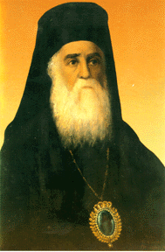 | Saint Nectarios Greek Orthodox Church and Shrine | 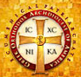
Home | About_Us | Calendar | Bulletin | Ministries | Sacraments/Blessings | Donations | Our_Faith | Stewardship | Church_Hall

The Iconostasis, Royal Doors, and Deacon’s Doors

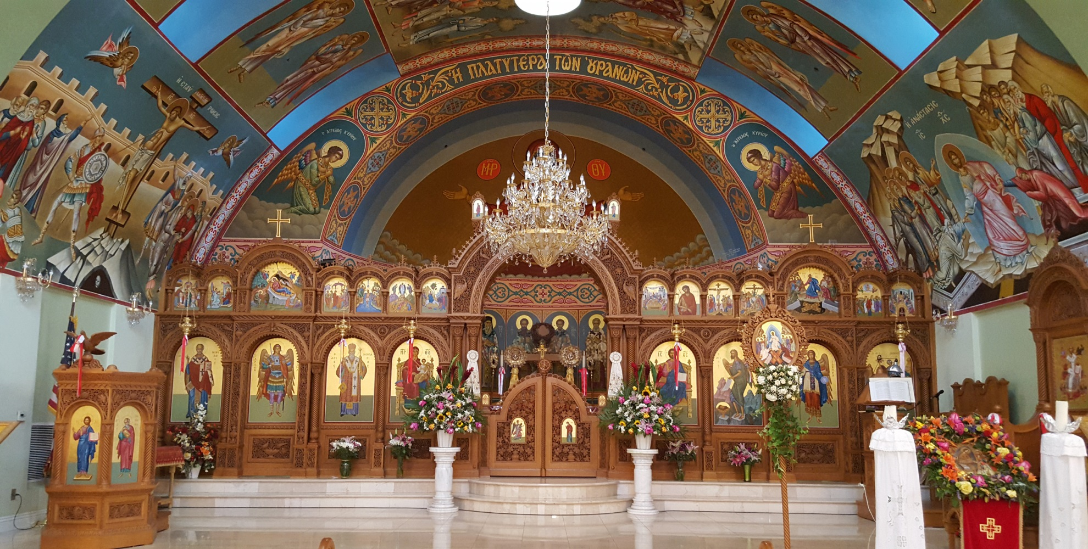
 | ^  |  |  Deacon’s Doors | ^  |  |  Royal Doors | ^  |  |  Deacon’s Doors
 | < ------------------- Iconostasis -------------------->

The Royal Doors, holy doors, or beautiful gates are the central doors of the iconostasis in an Eastern Orthodox. In Orthodox Churches, the sanctuary is separated from the nave by a wooden screen called the iconostasis and located east end of the church. The iconostasis represents Christian continuity from the veil of the Temple in Jerusalem which separated the people from the Holy of Holies that housed the Ark of the Covenant. Normally, the iconostasis has three doors in it. The two single doors to the right and left are called "deacons' doors" or "angel doors" and they usually have on them icons of either sainted deacons (Saint Stephen, Saint Lawrence, etc.) or the Archangels Michael and Gabriel. These are the doors that the clergy will normally use when entering the altar. The central double doors are the "Royal Doors or Holy Doors or beautiful gates", which are considered to be most sacred, and may only be entered at certain sacred moments during the services, and only by ordained clergy (deacons, priests, bishops).

The term Royal Doors is commonly used to describe the Holy Doors, because Christ passes through these gates during the Great Entrance at the Divine Liturgy (and most especially during the Liturgy of the Presanctified Gifts).

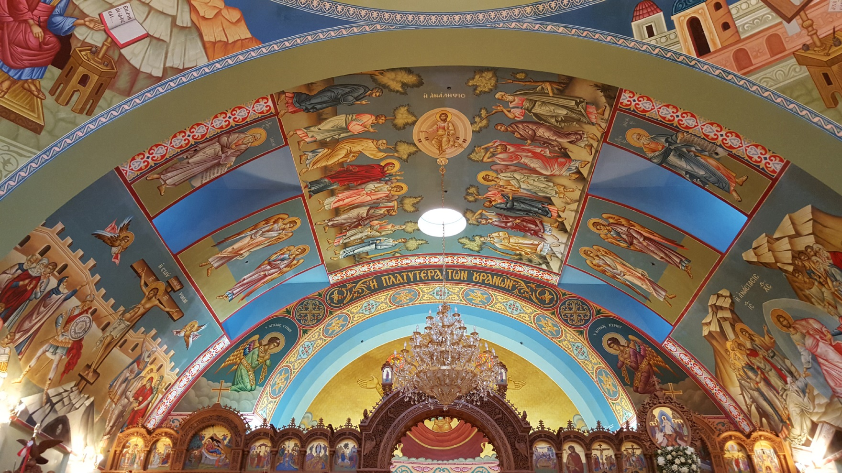
Nave’s east end ceiling

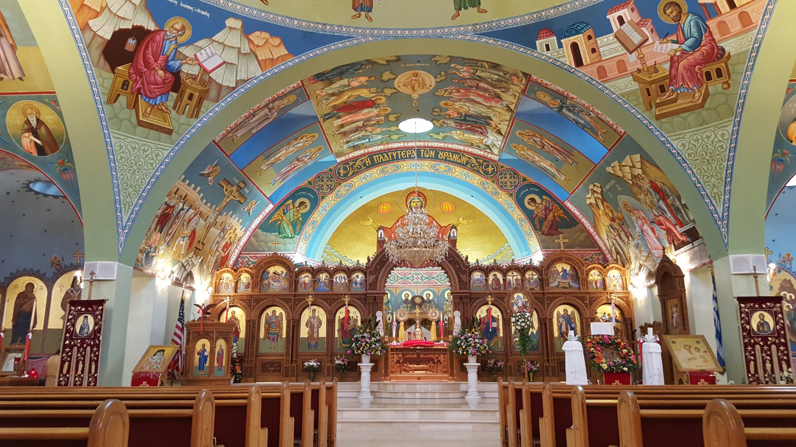
Full view of Iconostasis or Templon

PREVIOUS PAGE |  | NEXT PAGE

|About Us | Contact Us | Visitor Info | Donate | Our Faith | Ministries | Calendar | Metropolis News | Archdiocese News |Sacraments|

© 2017 Saint Nectarios Greek Orthodox Church and Shrine. This site has been designed and developed by Joey M. Eugenio and hosted by WebSBA

