You are viewing The Icons on the Right Side Wall of the Church

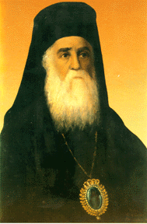 | Saint Nectarios Greek Orthodox Church and Shrine | 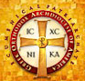
Home | About_Us | Calendar | Bulletin | Ministries | Sacraments/Blessings | Donations | Our_Faith | Stewardship | Church_Hall

Icons on the right side (south) wall

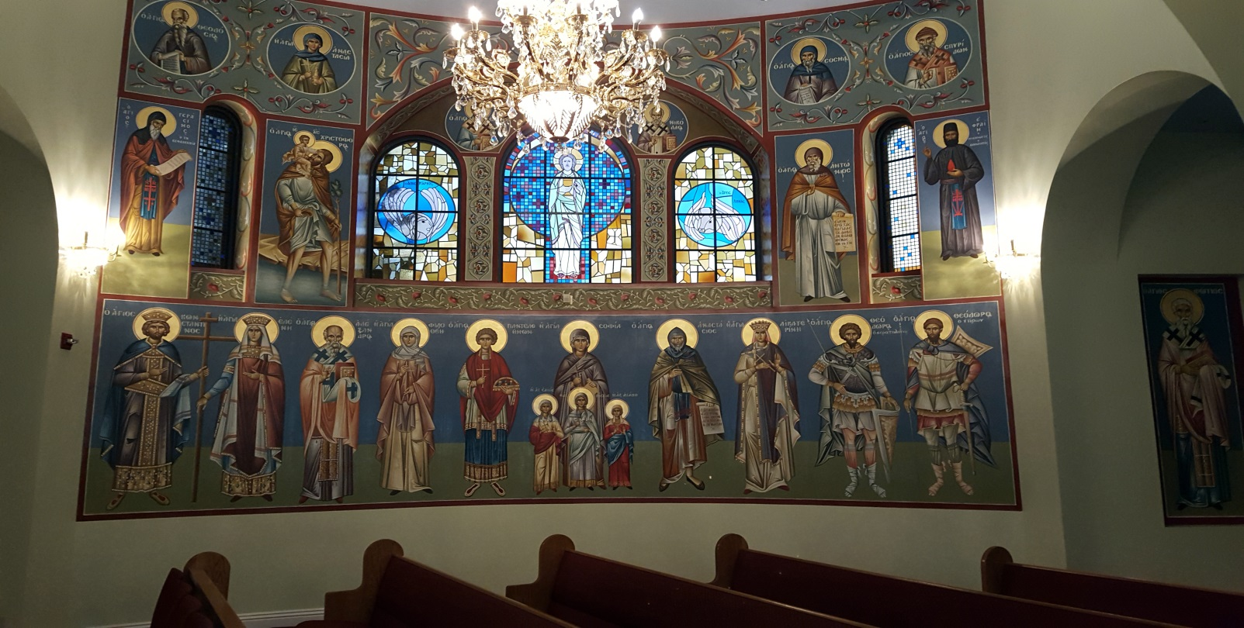

 | PREVIOUS PAGE |  | NEXT PAGE

|About Us | Contact Us | Visitor Info | Donate | Our Faith | Ministries | Calendar | Metropolis News | Archdiocese News |Sacraments|

© 2017 Saint Nectarios Greek Orthodox Church and Shrine. This site has been designed and developed by Joey M. Eugenio and hosted by WebSBA

