You are viewing the Left Side (North) Ceiling

Saint Nectarios Greek Orthodox Church and Shrine

Home | About_Us | Calendar | Bulletin | Ministries | Sacraments/Blessings | Donations | Our_Faith | Stewardship | Church_Hall

The Left Side Ceiling on the North Side of the Church

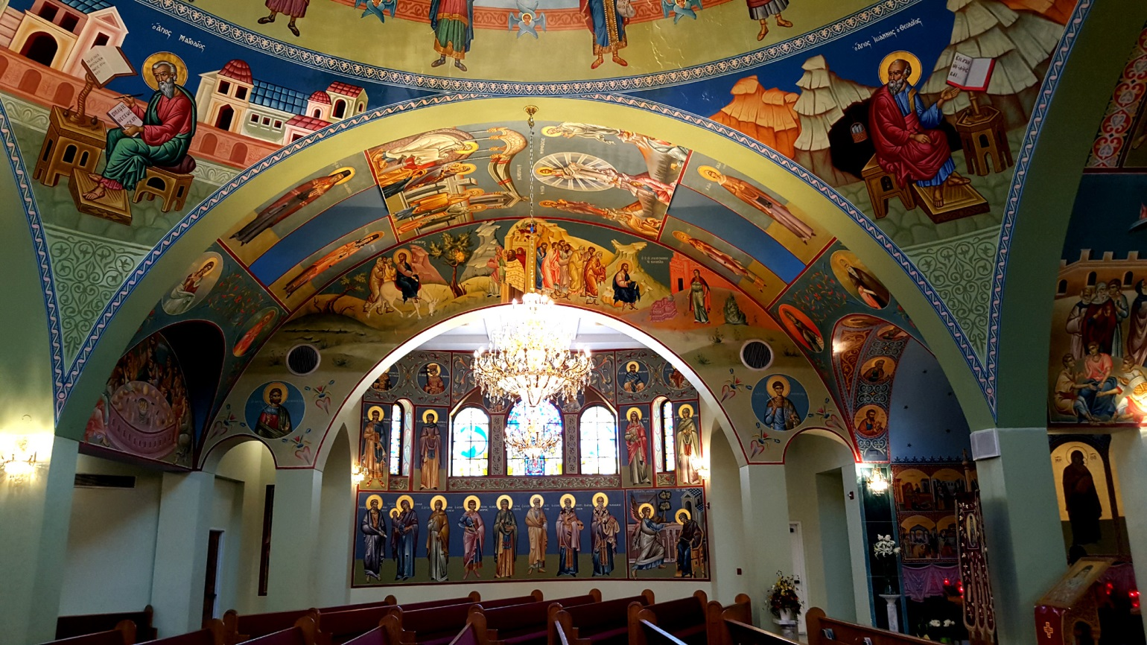

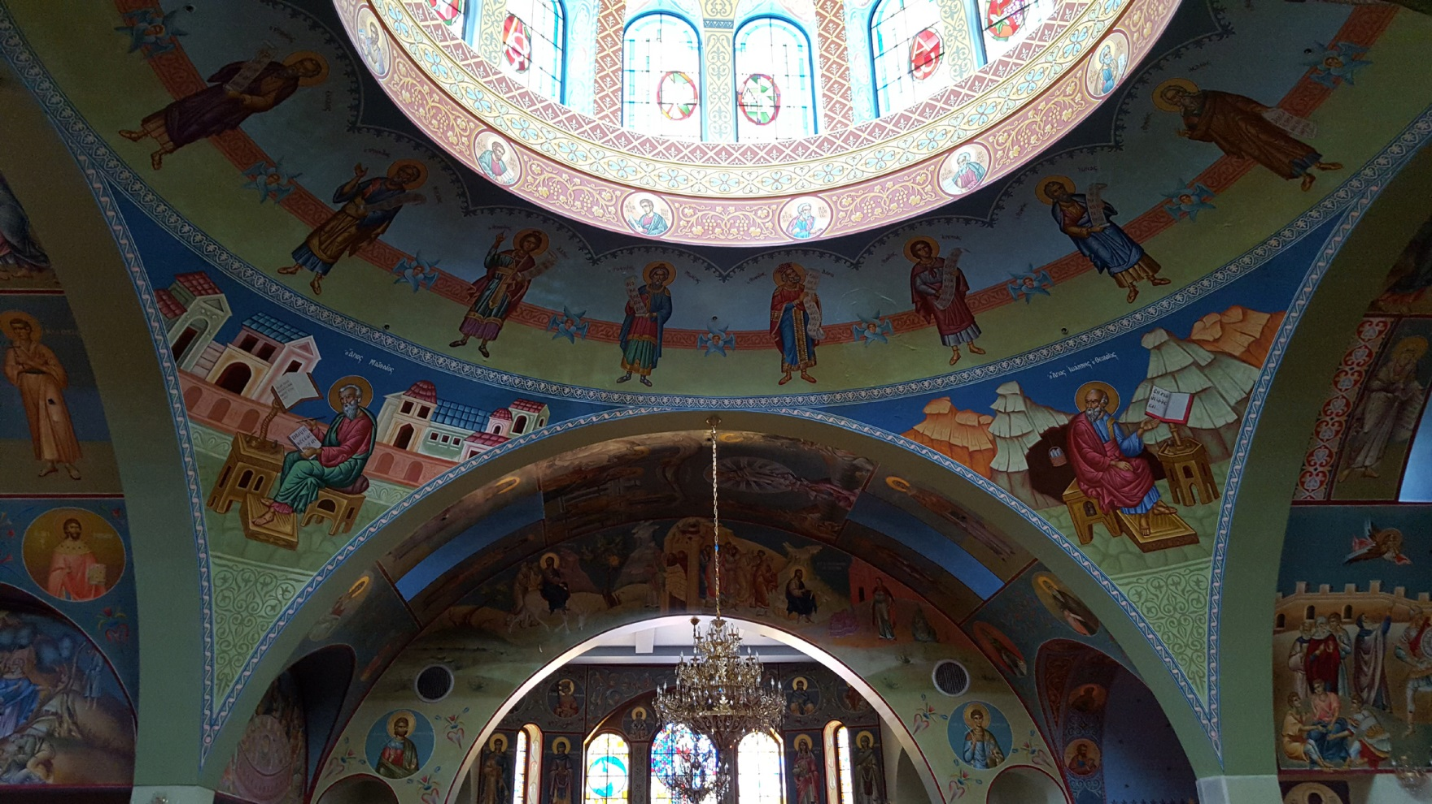

This is the left side ceiling on the north side of the church.

 | PREVIOUS PAGE |  | NEXT PAGE

|About Us | Contact Us | Visitor Info | Donate | Our Faith | Ministries | Calendar | Metropolis News | Archdiocese News |Sacraments|

© 2017 Saint Nectarios Greek Orthodox Church and Shrine. This site has been designed and developed by Joey M. Eugenio and hosted by WebSBA

