You are viewing the Main Entrance Page

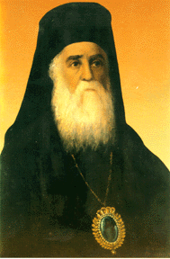 | Saint Nectarios Greek Orthodox Church and Shrine | 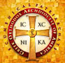
Home | About_Us | Calendar | Bulletin | Ministries | Sacraments/Blessings | Donations | Our_Faith | Stewardship | Church_Hall

The Main Entrance Doors View from the Narthex

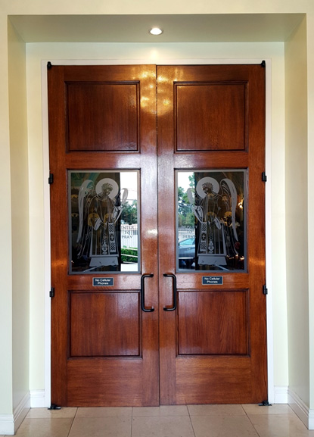

The Main Entrance Door indicates the large central doors that separate the Narthex from the Nave. This is the formal entrance to the church proper (i.e. the nave).

 | PREVIOUS PAGE |  | NEXT PAGE

|About Us | Contact Us | Visitor Info | Donate | Our Faith | Ministries | Calendar | Metropolis News | Archdiocese News |Sacraments|

© 2017 Saint Nectarios Greek Orthodox Church and Shrine. This site has been designed and developed by Joey M. Eugenio and hosted by WebSBA

